**BOREWELL RESCUE ROBOT USING ARDIUNO**



**Guided By Done By**

Mrs. BACKIALAKSHMI.S, S.SIVASANKARAN (174153)

Lecturer R.G.JEBBANATHAN (174114)

P.MANIMUTHU (174128)

M.RANJITHKUMAR (174145)

A.SACHIN TENDULKAR (174146)

S.SENTHILKUMAR (174148)

**Tamilnadu Government Polytechnic College (Autonomous), Madurai Department of Computer Engineering**

In Partial fulfilment of the requirements for the award of Diploma in Computer Engineering of the Directorate of Technical Education, Chennai- 25

**BOREWELL RESCUE ROBOT USING ARDIUNO**



**Guided By Done By**

Mrs. BACKIALAKSHMI.S, S.SIVASANKARAN (174153)

Lecturer R.G.JEBBANATHAN (174114)

P.MANIMUTHU (174128)

M.RANJITHKUMAR (174145)

A.SACHIN TENDULKAR (174146)

S.SENTHILKUMAR (174148)

**Tamilnadu Government Polytechnic College (Autonomous), Madurai Department of Computer Engineering**

In Partial fulfilment of the requirements for the award of Diploma in Computer Engineering of the Directorate of Technical Education, Chennai- 25

**BONAFIDE CERTIFICATE**

Certified that this project repot **‘BORE-WELL RESCUE ROBOT USING ARDIUNO’** is the bonafide work of ____________________ who carried out the project work under any supervision.

**SINGNATURE OF THE GUIDE SINGNATURE OF THE H.O.D**

Mrs. BACKIALAKSHMI.S, Mrs. T.HEMACHITRA M.E.,

Lecturer HOD(i/c),

Department of Computer Engg., Department of Computer Engg.,

Tamilnadu Government polytechnic Tamilnadu Government polytechnic college, college,

Madurai – 11. Madurai – 11.

Submitted for the board Examination held on __________________.

**INTERNAL EXAMINER EXTRNAL EXAMINER**

**ABSTRACT**

In recent times we have gone through many incidents of children falling into bore-wells. Usually the rescue team dugs a big hole parallel to the bore-well which takes almost 20-60hrs. Then trained army person will move inside the bore-well and rescue the child. In such cases, a small delay may reduce the chances of saving the child alive. To overcome the issues, we have proposed a system called “bore-well rescue robot”, in which the robot can move inside the bore-well and rescue the child safely. This project is easily portable and less expensive which can be used in any situation to rescue the child safely and also in less time.

**TABLE OF CONTENS**

|  |  |  |
| --- | --- | --- |
| **CHAPTER** | **TITLE** | **PAGE NO** |
| **1** | **INDRODUCTION** | **1** |
| **2** | **SYSTEM ANALYSIS**  2.1 EXISTING SYSTEM  2.2 PROPOSED SYSTEM | **2**  **3** |
| **3** | **SYSTEM SPECIFICATION**  3.1 HARDWARE SPECIFICATION  3.2 SOFTWARE SPECTIFICATION | **4**  **4** |
| **4** | **PIN DIAGRAM** | **5** |
| **5** | **MODULE DESCRIPTIONS** | **6** |
| **6** | **SAMPLE CODE** | **11** |
| **7** | **SCREENSHOTS** | **15** |
| **8** | **CONCLUSION** | **17** |
| **9** | **REFERENCES** | **18** |

**INDRODUCTION**

**INDRODUCTION**

During the year 2019 in March Nadim, an 18-month-old child, was safely rescued after he fell into a 60-foot deep borewell while playing near his house in Balsam and village in Hisser district of Haryana. Nadim was rescued after a 48-hour-long struggle by the army and NDRF personnel. In the month of February Six-year-old Ravi Panduit Bhili was stuck at a depth of 10 feet in a 200-foot-deep borewell in Maharashtra's Pune district early this year. He was out after a 16-hour-long operation after falling into the borewell. He was playing near the borewell while his father, a labourer, was busy with road construction work. In January A 3-year-old boy was rescued after falling into a 30-foot-deep borwell in Singrauli district. The child fell inside the borewell at his father's farm. A team rushed to the spot and the kid was rescued after a [three-hour](https://timesofindia.indiatimes.com/city/bhopal/madhya-pradesh-3-year-old-rescued-from-borewell-in-singrauli/articleshow/67718818.cms) operation.

Normal rescue operation strategy involves digging a parallel pit to save the child and adjacent holes are made near to the walls of borewell. But these are time consuming and may cost life. A multifunctional, reprogrammable and intelligent manipulator designed to perform a task is a robot.

**1**

**SYSTEM ANALYSIS**

**EXISTING SYSTEM**

In the existing system, if a child is stuck in a borewell the rescue operation involves digging a big hole adjacent to the borewell. It is dug up to the depth where the child is stuck. In this method there are many factors that affect the time take to rescue. If there is any problem in the digging process it will take more time to complete the rescue operation. Also, a correct person is needed to be sent into the hole to rescue the child.

**DISADVANTAGES:**

1. Lack of oxygen inside the borewell and lack of light sources causes the major difficulty during the rescue operation.
2. There is no such special equipment for rescuing the child trapped inside the borewell.
3. In last ten years, a lot of lives has been lost due to falling in borewell because it.
4. The latest borewell rescue robot is only robot arm fixed.
5. There is no light to see the child.

**2**

**PROPOSING SYSTEM**

The main objective of the current research is to develop a smart child rescue robot using simplified method within a short span of time. This goal is achieved by controlling a robot to take of the child inside the borewell which is controlled by the person from outside. Now-a-days, various methods were adopted for saving the held child from the borewell. Here we propose a model which is very unique in its structure and also lifting mechanism.

**ADVANTAGES:**

1. This borewell rescue robot is uses body and robot arm to rescue the child.
2. Led light is fixed in this robot.
3. Web camera is also fixed in this robot to see the child easily.
4. The robot is controlled by simple coding. Which is inserted into the Arduino board.

**3**

**SYSTEM SPECIFICATION**

**HARDWARE SPECIFICATION:**

**System:**

1. HARD DISK : 500GB
2. RAM : 4GB
3. SPEED : 3GHz
4. PROCESSOR : INTEL - i3 CORE

**Embedded Kit**:

1. KIT : ARDIUNO BOARD
2. DRIVER : L298N-12V DRIVER
3. MOTOR : 12V-MOTOR
4. BATTERY : 12V

**SOFTWARE SPECIFICATION:**

1. LANGUAGE : EMBEDDED C
2. OS : WINDOWS

**4**

**PIN DIAGRAM**

**PIN DIAGRAM**

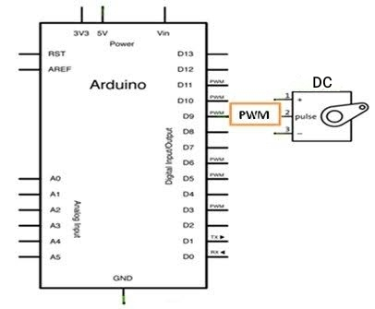

**5**

**MODULE DISCRIPTIONS**

**MODULE DISCRIPTIONS**

1. DESIGN AND INITIALIZATION
2. ROBOT TELEOPERATION
3. RESCUING ROBOT

**6**

**DESIGN AND INITIALIZATION:**

**Design Helical Spring:**

***Uses*:**

1. Spring is used to robot for flexibility.
2. It will help the robot in to the pipe stable.

**Translational Element:**

***Uses*:**

1. It joins the three frames of the link.
2. It is used to compress and depress the spring.

**Distance Between the Extreme Drilled Holes:**

***Uses:***

1. It is used to join all the links.

2. It is used to connect all motors and tires**.**

**Central Element:**

***Uses:***

1. It is the central part of robot.
2. Camera and robot arm is connected in the central part.
3. All parts are connected to the central part.

**7**

**Robot arm:**

***Uses:***

1. It is used to child rescue.
2. It extends to 12 cm.
3. This robot arm is control by dc motor.

**8**

**ROBOT** **TELEOPERATION:**

1. Manually monitoring the child with the help of camera and controlling unit of system.
2. The six wheels in this robot three wheels are supported and the other three wheels are connected in the motor.
3. When operating the robot there are a total of six wheels of which there is a three wheelers motor will other three wheels up and down moving when run the robot.
4. The webcam of this robot is set up so that is can detect the situation inside the deep well.
5. The camera in this robot it is used to take the next step after finding the problems.
6. Underneath the robot a robotic arm similar to human fingers is placed.

**9**

**RESCUE:**

1. Once the system has reached proximity of child, it is stopped immediately and is given the commands by the controlling device to perform the closing of the systemic arms.
2. Controlling a system to takeoff the child inside the borewell, which is controlled by the person from outside.
3. The human finger robot helps to retrieve objects and child that is stuck inside.

**10**

**SAMPLE CODE**

**SAMPLE CODE:**

//Code by Reichenstein7 (thejamerson.com)

// Modified by SRN for KEYES Robot

//Keyboard Controls:

//

// 1 -Motor 1 Left

// 2 -Motor 1 Stop

// 3 -Motor 1 Right

//

// 4 -Motor 2 Left

// 5 -Motor 2 Stop

// 6 -Motor 2 Right

// Declare L298N Dual H-Bridge Motor Controller directly since there is not a library to load.

// Motor 1

int dir1PinA = 7; // wire this pin to IN1 on L298N

int dir2PinA = 8; // wire to IN2

int speedPinA = 9; // Needs to be a PWM pin to control motor speed, wire to ENA on L298N

// Motor 2

int dir1PinB = 12; // wire this pin to IN3 on L298N

int dir2PinB = 11; // wire to IN4

int speedPinB = 10; // Needs to be a PWM pin to control motor speed, wire to ENB on L298N

**11**

void setup() { // Setup runs once per reset

// initialize serial communication @ 9600 baud:

Serial.begin(9600);

//Define L298N Dual H-Bridge Motor Controller Pins

pinMode(dir1PinA,OUTPUT);

pinMode(dir2PinA,OUTPUT);

pinMode(speedPinA,OUTPUT);

pinMode(dir1PinB,OUTPUT);

pinMode(dir2PinB,OUTPUT);

pinMode(speedPinB,OUTPUT);

}

void loop() {

// Initialize the Serial interface:

if (Serial.available() > 0) {

int inByte = Serial.read();

int speed; // Local variable

switch (inByte) {

//______________Motor 1______________

case '1': // Motor 1 Forward

analogWrite(speedPinA, 255);//Sets speed variable via PWM

digitalWrite(dir1PinA, LOW);

digitalWrite(dir2PinA, HIGH);

Serial.println("Motor 1 Forward"); // Prints out “Motor 1 Forward” on the serial monitor

**12**

Serial.println(" "); // Creates a blank line printed on the serial monitor

break;

case '2': // Motor 1 Stop (Freespin)

analogWrite(speedPinA, 0);

digitalWrite(dir1PinA, LOW);

digitalWrite(dir2PinA, HIGH);

Serial.println("Motor 1 Stop");

Serial.println(" ");

break;

case '3': // Motor 1 Reverse

analogWrite(speedPinA, 255);

digitalWrite(dir1PinA, HIGH);

digitalWrite(dir2PinA, LOW);

Serial.println("Motor 1 Reverse");

Serial.println(" ");

break;

//______________Motor 2______________

case '4': // Motor 2 Forward

analogWrite(speedPinB, 255);

digitalWrite(dir1PinB, LOW);

digitalWrite(dir2PinB, HIGH);

Serial.println("Motor 2 Forward");

**13**

Serial.println(" ");

break;

case '5': // Motor 1 Stop (Freespin)

analogWrite(speedPinB, 0);

digitalWrite(dir1PinB, LOW);

digitalWrite(dir2PinB, HIGH);

Serial.println("Motor 2 Stop");

Serial.println(" ");

break;

case '6': // Motor 2 Reverse

analogWrite(speedPinB, 255);

digitalWrite(dir1PinB, HIGH);

digitalWrite(dir2PinB, LOW);

Serial.println("Motor 2 Reverse");

Serial.println(" ");

break;

default:

// turn all the connections off if an unmapped key is pressed:

for (int thisPin = 2; thisPin < 11; thisPin++) {

digitalWrite(thisPin, LOW);

}

}

}

**14**

**SCREENSHOTS**

**SCREENSHOTS**

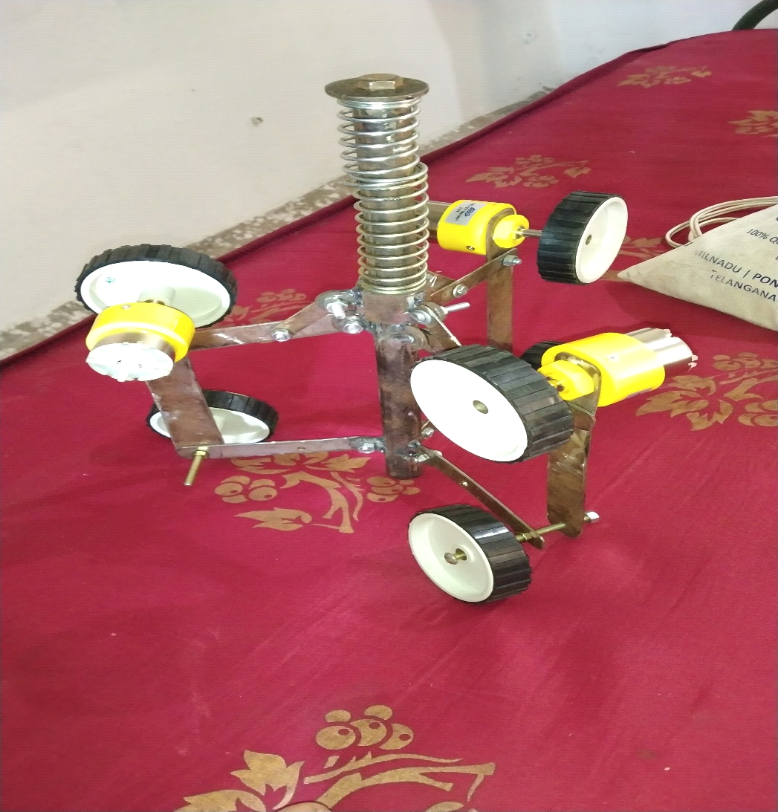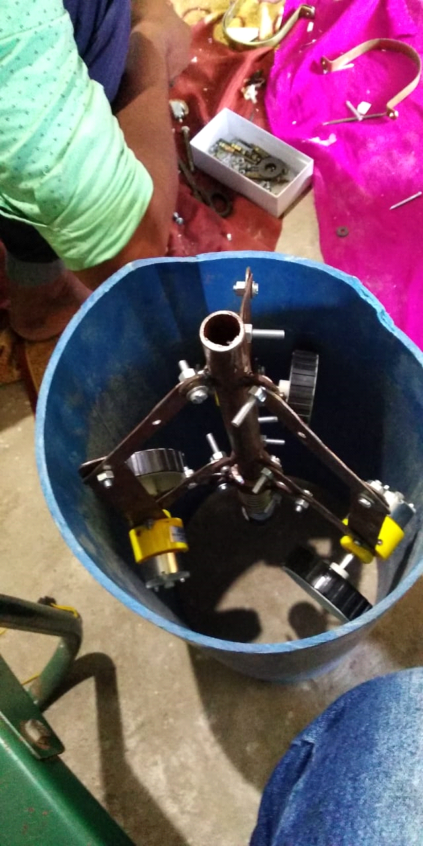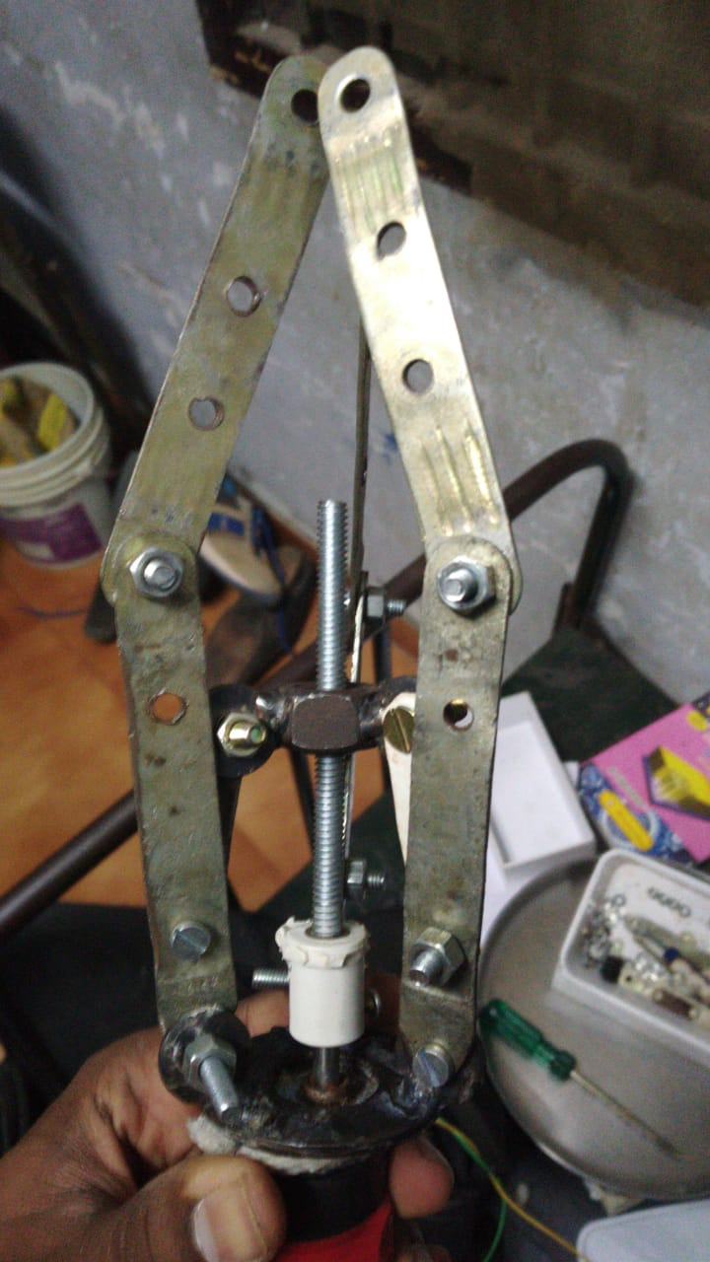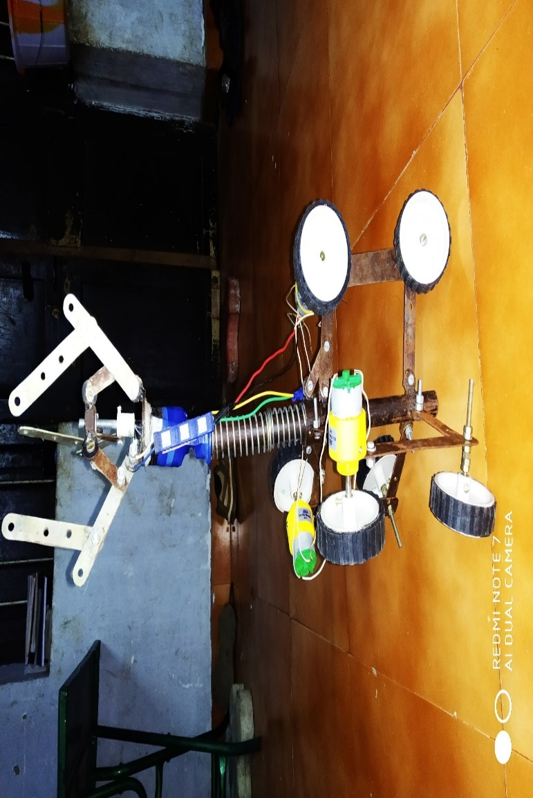

**15**

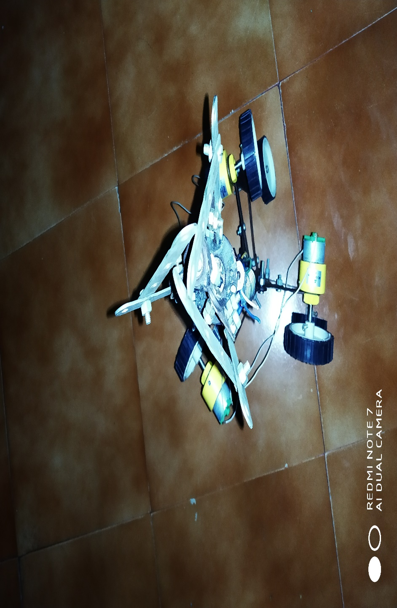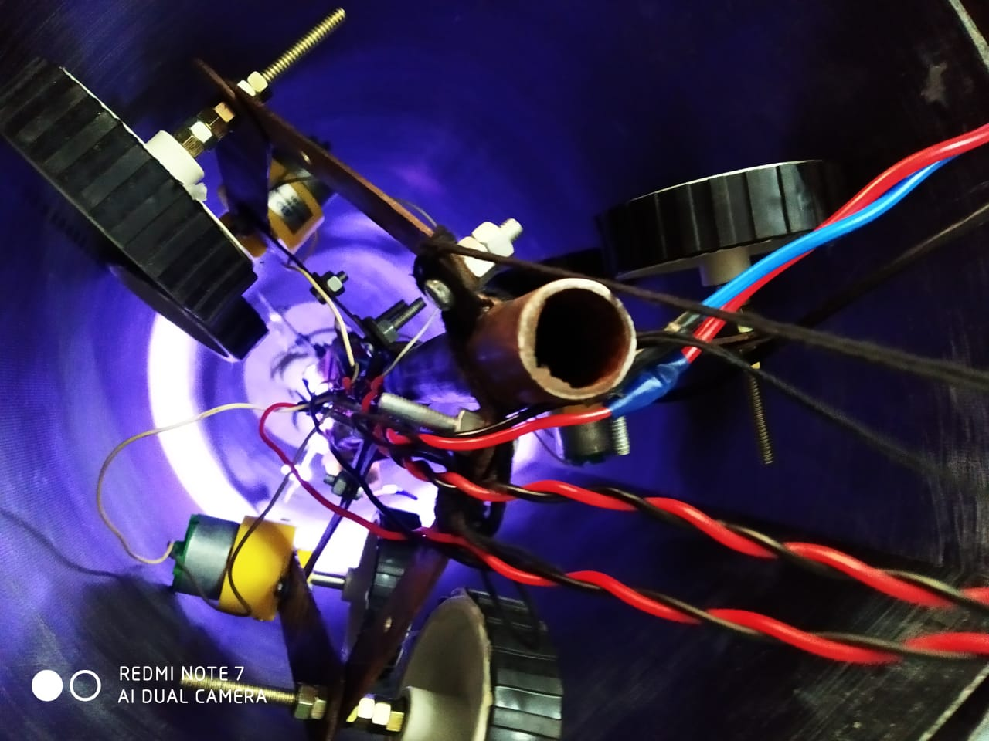 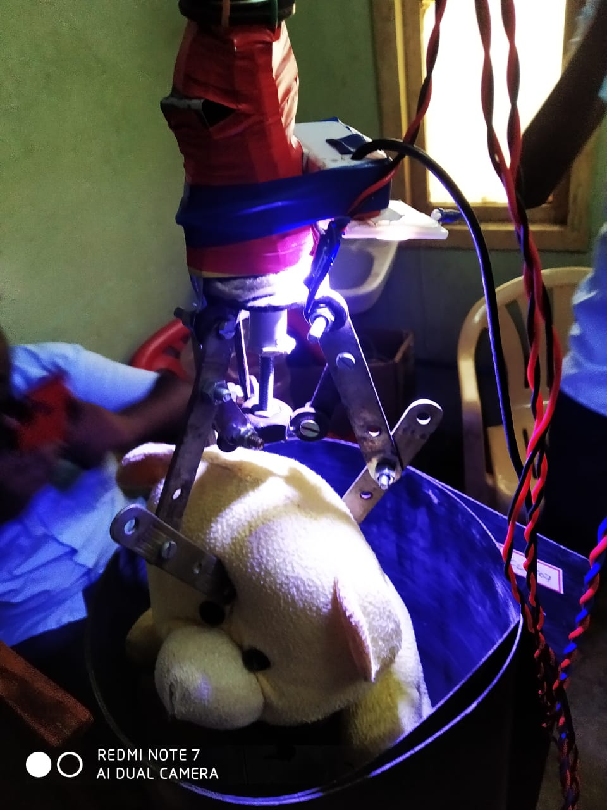

**16**

**CONCLUSION**

**CONCLUSION**

At present, instruments or devices to rescue the child who stuck in the borewell is not available in the fire stations because of lack of efficiency and possible of failures in existing instruments. So, we designed a robot which is of high efficiency in rescuing the robot and these is no possibility of failures while rescuing. Also, it is cost effective so that the needed persons could afford it easily. The device can be controlled easily. It have live camera feed which can be used to locate the child stuck in the borewell. Through this we can safe guard the child without any possibilities of failure and injury.

**17**

**REFERENCES**

**REFERENCES**

1. Horodinca M, Dorftei I, Mignon E and Premont A (2002), “A Simple Architecture for in Pipe Inspection Robots”, in Proc. Int.
2. Colloq. Mobile, Autonomous Systems, pp. 61-64.
3. Jordan Laneri and Roth B (2006), Advances in Robot Kinematics.
4. Mechanisms and Motion, 1st Edition
5. Mhramatsu M, Namoki N, Koyama U and Suga Y (2000), “Autonomous Mobile Robot in Pipe for Piping Operations”, in Proc.
6. IEEE/RSJ Int. Conf. Intelligent Robots, Systems, Vol.
7. Paul E Sandin (2003), Robot Mechanisms and Mechanical Devices, 1st Edition.

**18**